OSSP-SKILL-WEEK12
SESSION23:
Task1: Develop a program that launches multiple jobs connected through a pipeline, monitors their execution, detects failures, and measures execution performance.
Source code:
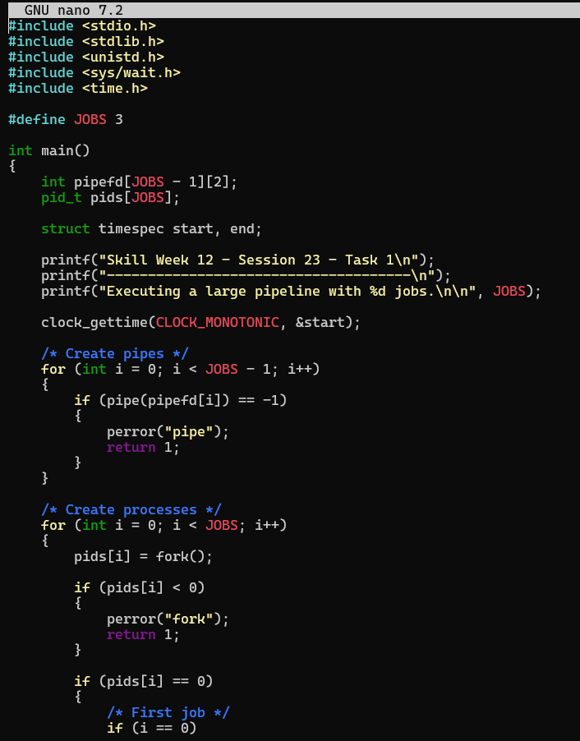
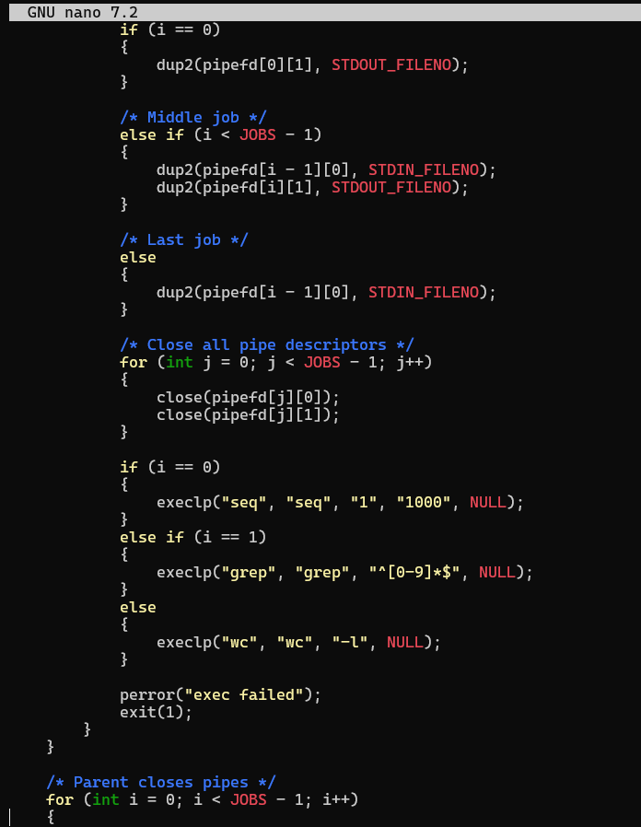
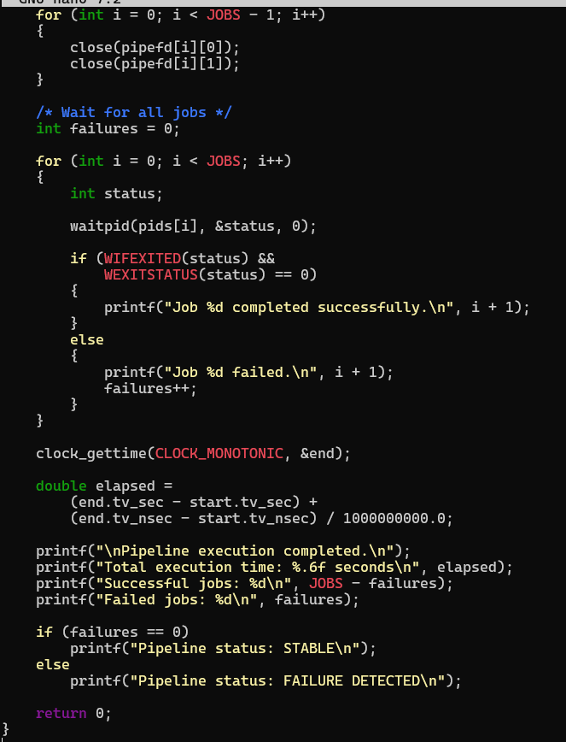
Output:
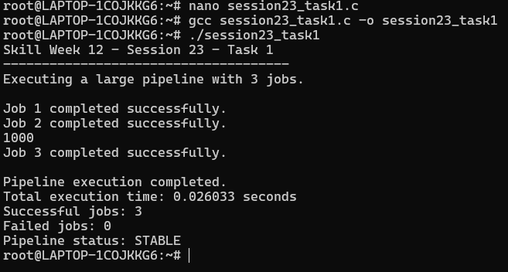
Observation: I learned how multiple processes can be connected using pipes to create large pipelines. I understood how fork(), pipe(), dup2(), exec(), and waitpid() work together for process execution, monitoring, failure detection, and performance measurement.
Task2: Document the shell architecture, create a flow diagram, explain execution paths, describe system calls, record design decisions, and review the documentation.
Source code:
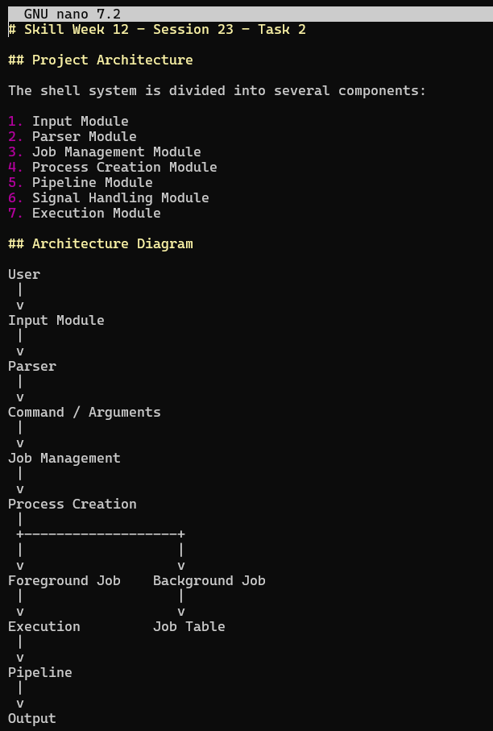
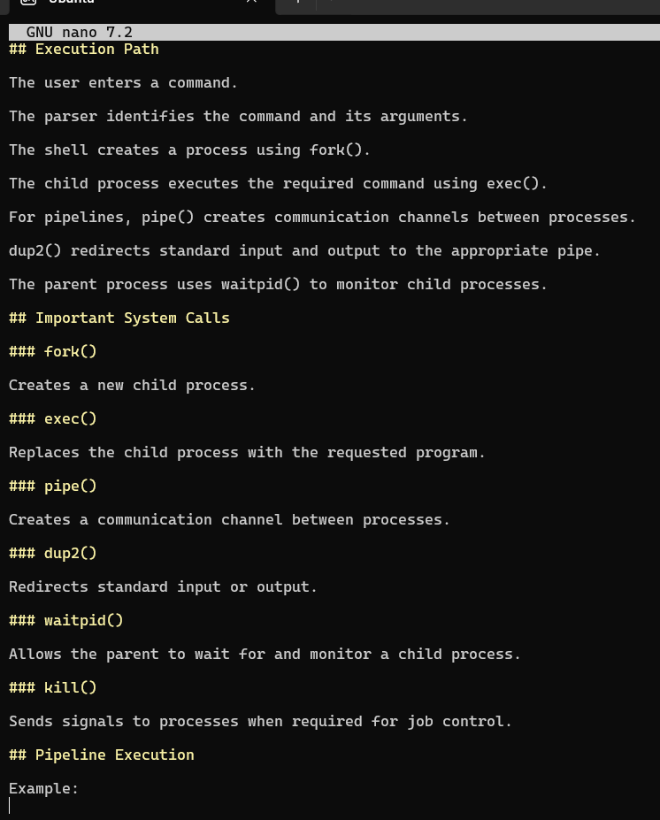
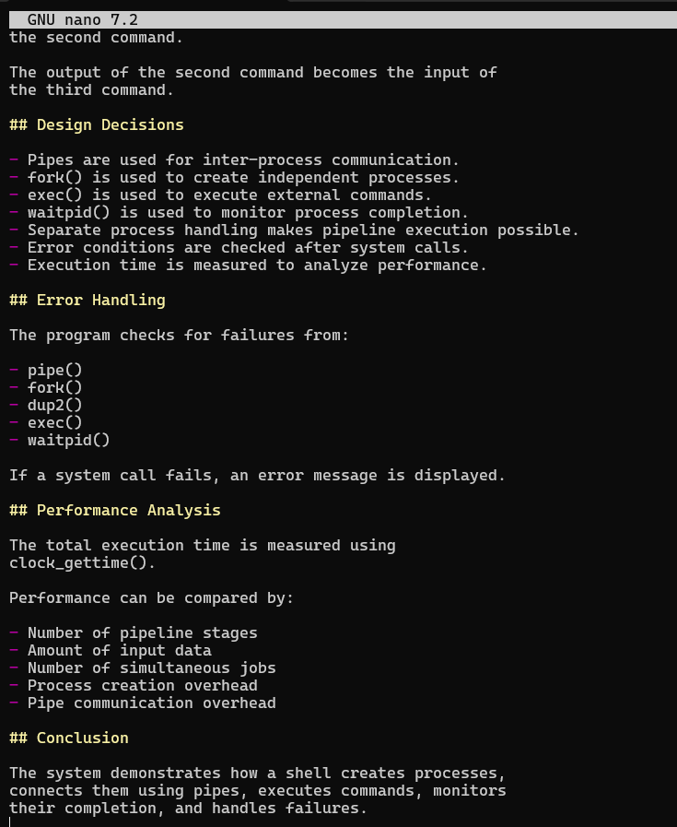
Output:
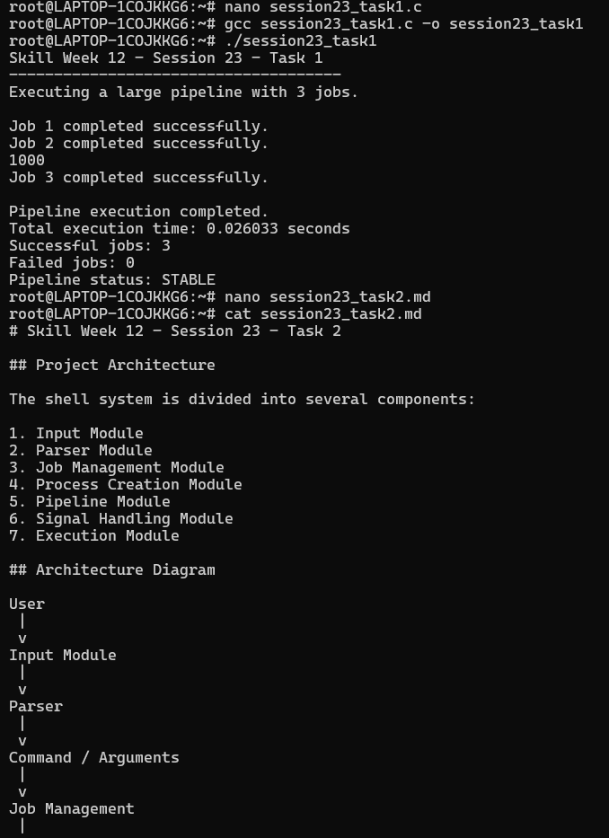
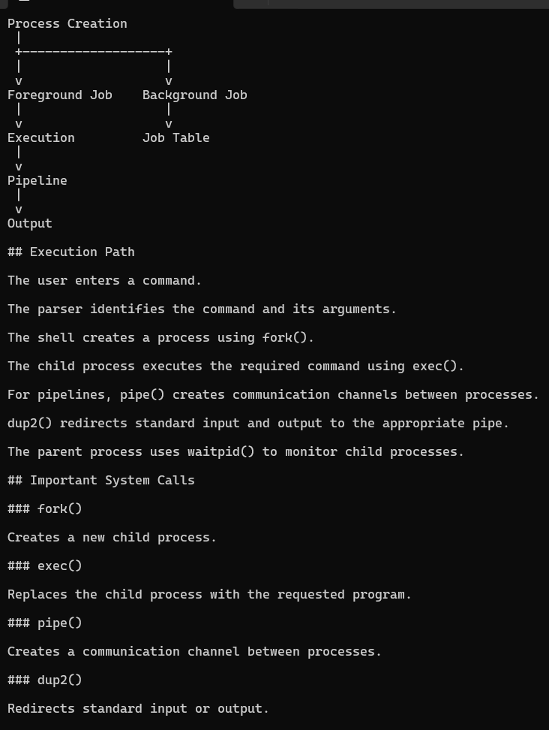
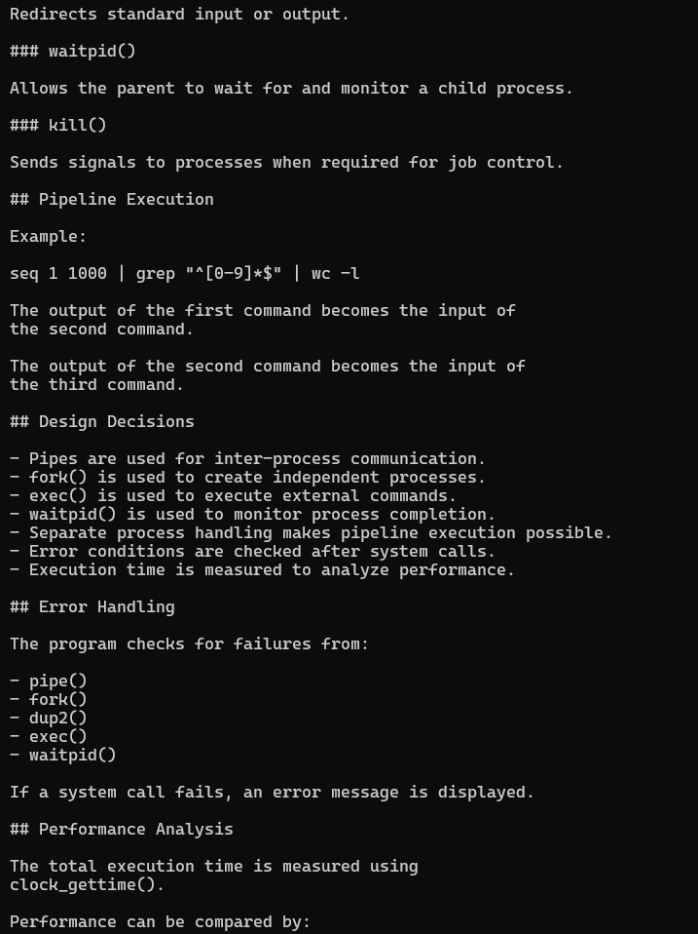
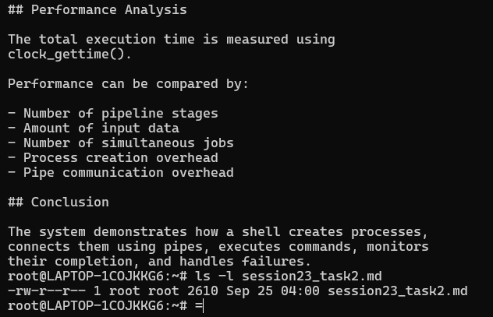
Observation: I learned how to document a system architecture and execution flow. I understood the role of important Linux system calls in the shell and learned how flow diagrams and design documentation help explain the complete execution process.
Session – 24
Task1: Organize the project source code, improve the build system, create project documentation, verify the repository structure, create a release tag, and validate the final deliverables.
Source code:
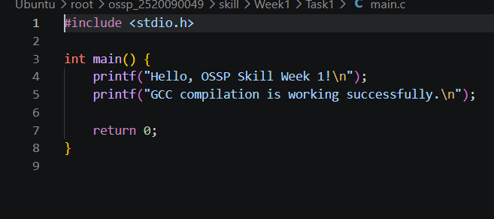
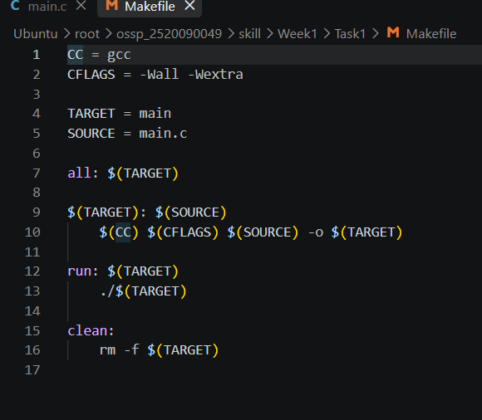
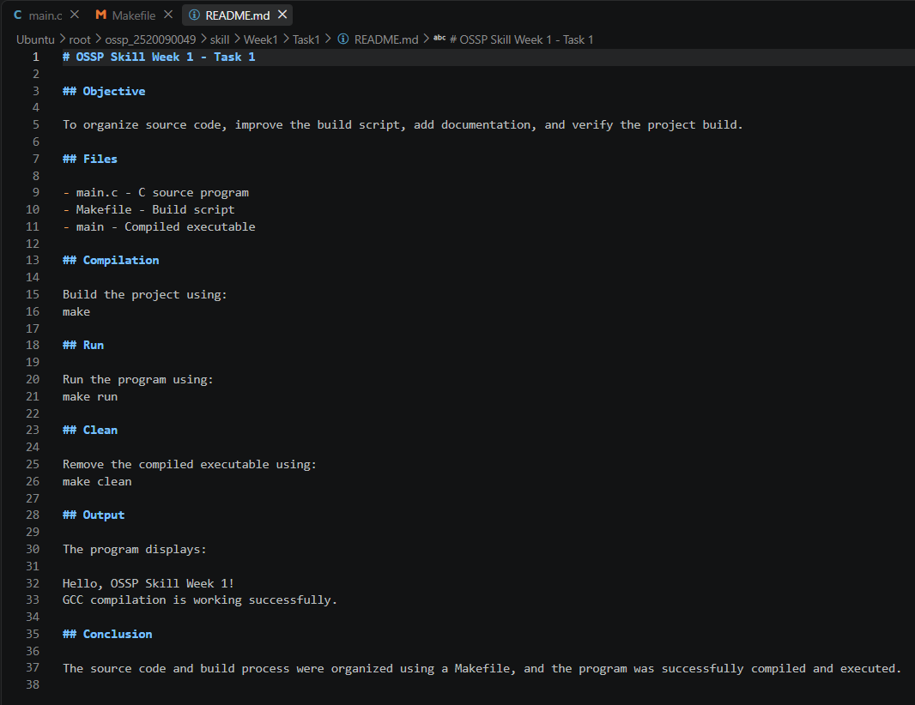
Output:
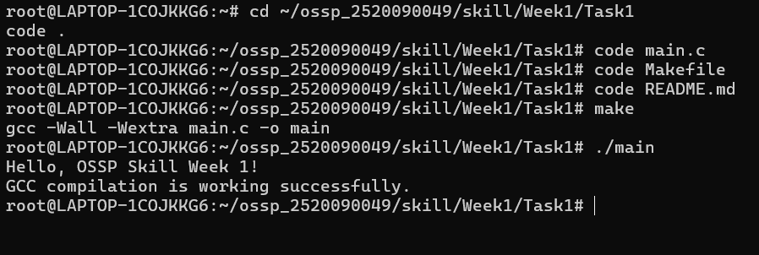
Observation: I learned how to organize source code and improve the build process using a Makefile. I understood how to compile, run, and clean a C program using Make commands. I also learned how to create project documentation using a README file, verify the project structure, and use Git commits and tags to manage project versions.
Task2: Create Demo Scenarios, Validate Features, Rehearse Presentation, Demonstrate Pipelines, Demonstrate Signals, Final Project Review
Source code:
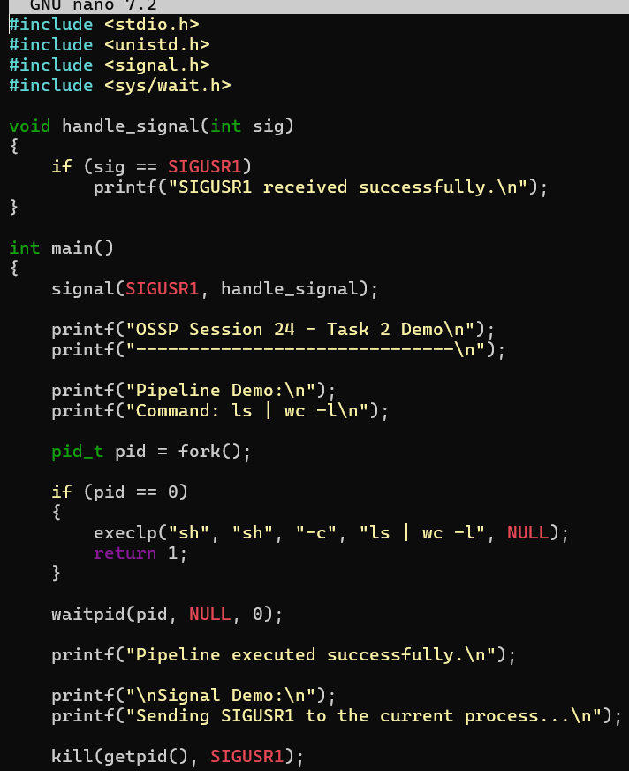
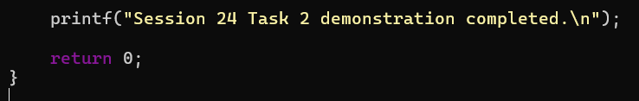
Output:
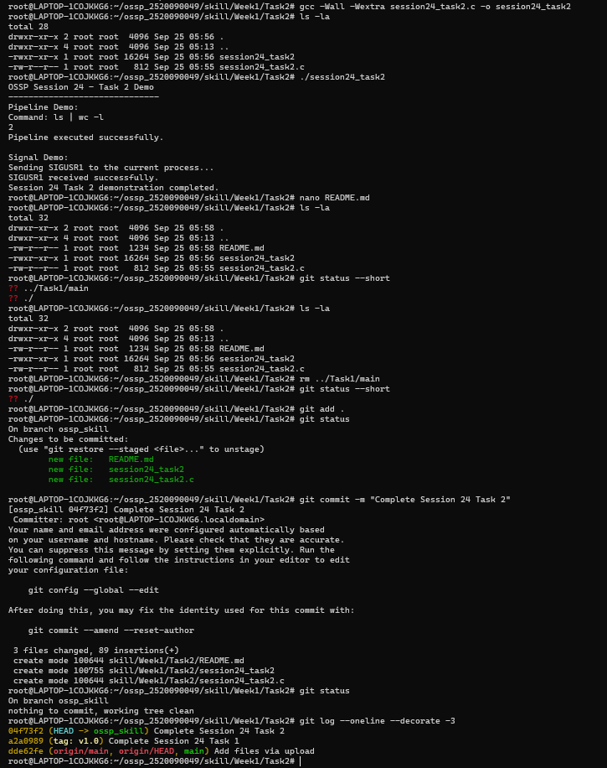
Observation: I learned how to demonstrate Linux pipelines and signal handling in a project review. I understood how commands can be connected using pipelines and how signals such as SIGUSR1 can be sent and handled by a process. I also learned how to organize, validate, document, and commit project deliverables using Git.

